**WEB APPLICATION FOR**

**E-COMMERCE PRODUCTS**

**“THE DIVINE FOODS”**

**ORGANIC PRODUCT**

**ABSTRACT**

An e-commerce website, by definition, is a website that allows you to buy and sell tangible goods, digital products or services online **(THE DIVINE FOODS)**. Trade, be it barter exchange or buying and selling of goods and services has been prevalent for centuries. No one can be self-sufficient. And this brings out the need for demand and supply of goods and services. Transactions have been going on all over the world for centuries, locally, and across locations. Keeping the same concept in mind, now think electronic. However, also bear in mind that with the whole world going online, data privacy laws have become increasingly stringent. And before you begin, an eCommerce venture you should be aware of all the legal policies required for your eCommerce website.

E-Commerce, also known as e-Business, or electronic business, is simply the sale and purchase of services and goods over an electronic medium, like the Internet. It also involves electronically transferring data and funds between two or more parties.

E-Commerce websites are online portals that facilitate online transactions of goods and services through means of the transfer of information and funds over the Internet. In the early days, e-commerce was done partially through emails and phone calls. Now, with a single website, anything and everything that a transaction needs, can be executed online. **(THE DIVINE FOODS)** E-Commerce websites are online portals that facilitate online transactions of goods and services through means of the transfer of information and funds over the Internet. In the early days, e-commerce was done partially through emails and phone calls. Now, with a single website, anything and everything that a transaction needs, can be executed online.

**How does eCommerce work?**

eCommerce is nothing but a type of commerce. Its functioning style is quite similar to that of the physical retail industry. The only difference it has with **organic product** store is that here, the entire process takes place online. The journey of an eCommerce firm begins with setting up an eCommerce website. It is usually done with plugins like WooCommerce. After that, the products are displayed along with necessary details like product descriptions and price tags. A CTA button like “Buy Now” is placed near the products for the convenience of the customers. If they feel like buying a product they can simply click on the button and make the payment. Customers are usually asked to place their orders by filling up a form. There, they need to provide all the necessary details like the delivery address. There are different payment methods used in the eCommerce industry. Buyers either can make the payment through a payment gateway like PayPal or they can use their credit cards. There is another option called COD or cash on delivery. This is mainly preferred by senior customers. In this option, the buyer makes the payment when the item they ordered is delivered on their personal address. The payment can be made either in cash or through cards or other convenient options like Google Pay. If you are not happy with the quality of the product or mistakenly a different product gets delivered to you, you can use the reverse logistics system. It is simply returning the items and getting the money back. You need to notify that you want to return the product you ordered. A representative of the company will come to you and take the product back. The money will be cashed to your account. The product promotion in eCommerce is also done digitally. The two most prominent methods are a digital advertising and email marketing. Ads are placed on the social media platforms which are most preferred by the target groups. All visitors are asked to provide their email addresses. Based on that an email list is prepared. After that personal emails are sent. Sometimes personal notifications are also sent to the social media accounts of the prospect costumes.

**WORDPRESS**

**Features of WordPress:**

WordPress is such a widely used website content management system, here are some of the benefits of WordPress as a website platform:

**Simplicity:**

WordPress allows you to publish and build your website content quickly. Even as a beginner, you can easily use WordPress.

The cost is free – The actual WordPress software available on WordPress.org is free to download and use. You will, however, need to pay for web hosting and a domain name.

**Flexibility:**

WordPress allows you to create many types of websites from personal blogs and online stores to online magazines and newspapers.

**Easy to use:**

If you can use a word processing software like Microsoft Word, you can use WordPress to build and manage a website.

**Open-source software:**

WordPress is open-source software that is licensed under the GNU General Public License (GPL), meaning it isn’t owned by a single company or entity. Hundreds of developers and users collaborate and contribute to the software to make it better. The spirit of open-source means constant improvements, accountability and free usage for everyone.

**No need to know code:**

WordPress removes the requirement of needing to know how to code in order to build a website. While WordPress utilizes a variety of coding languages, there’s no need to know any of them to use WordPress.

**Extendable with WordPress plugins:**

The core WordPress software can be extended with WordPress plugins. WordPress plugins are bits of software that you can upload to your website to add more features (such as e-commerce, SEO, backups, contact forms and more). There are thousands of free WordPress plugins available on the WordPress.org plugin directory and a thriving premium (paid) plugins industry.

**Highly customizable with WordPress themes:**

WordPress themes provide the design and layout of your website. With a click of a button, you can change the entire look of your website by applying a new WordPress theme. More advanced WordPress themes are more like WordPress page builders, giving you even more control of your layouts.

**Website security:**

While no website platform is 100% secure, WordPress security continues to improve with a vigilant security team of core developers and users. Common WordPress security issues are usually due to user error, rather than the software itself.

**A thriving community of users and developers:**

When you have a WordPress website, you can also get involved in the greater WordPress community through your local WordPress Meetup, Word Camps and more. The WordPress community has a reputation of being incredibly welcoming, helpful and innovative.

**A premium plugin and theme industry:**

While there are loads of free plugins and themes, most serious WordPress website owners invest in premium (paid) plugins or themes. Why? Your purchase of a reputable premium plugin or theme helps pay for the ongoing development and support of the plugin or theme, including new features, security patches and more.

**7 Reasons why I love the WooCommerce & WordPress combo for making an eCommerce website**

* Suits every budget
* Easy to use (especially for people who already use WordPress)
* Hundreds of extensions (plugins)
* Can sell all kinds of goods (virtual, physical, downloadable, services, etc.)
* Works with almost all payment gateways
* Open source – can be customized to suit our needs
* Big community of developers, marketers, and experts

**Installing WordPress**

1. Godaddy and almost every major web hosting service provider offers 1-Click Installation for WordPress and other CMSs such as Joomla and Drupal.
2. Below are the steps to install WordPress using the 1-Click Installation feature:
3. Log into Godaddy (Or any web host you are using)
4. Go to the control panel
5. Click on the WordPress icon (Install WordPress) which you can find under the website section
6. Install WordPress in Godaddy
7. Choose the domain where you’d like to install WordPress
8. Enter the site name, admin username and admin password of your choice, and once you’re done, click on Install Now
9. Congratulations! You’ve successfully installed WordPress, and now you are ready to install the WooCommerce plugin and start building your e-commerce site.

**Website Details**

1. Home Page
2. About Us
3. Shop Now
4. Login/Registration
5. Contact Us
6. What We Do
7. Products
8. Chatbot Integration

**SoftwareRequirements**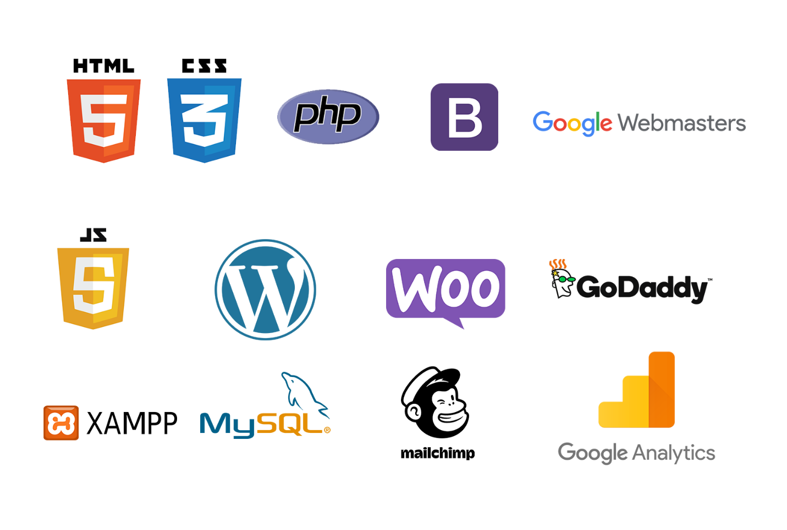

* HTML
* CSS
* Bootstrap
* PHP
* JavaScript
* My SQL
* SEO
* Woo-commerce
* Google Analytics
* Google Webmaster
* Plugins
* Email Marketing
* WordPress
* XAMPP
* Godaddy
* Zoho Mail

**UML:**

UML (Unified module language)UML. It is used for constructing and documenting a system or a project. This is widely used by people such as engineers to make module structures of what they want to build

**XAMPP**

XAMPP is an integrated development surrounding, which incorporates Apache HTTP Server, MySQL Database, and PHP, Mercury, PERL or Python on a home Windowsbased computer. Apache is a free web server. MySQL is an open source database. XAMPP is used in collaboration with, PHP, MySQL and, Windows 8 operating system./

**Bracket(Editor)**

Brackets is a free-source editor written in HTML, CSS, and JavaScript. It is created via Adobe structures, certified underneath the MIT License, and is presentlymaintained on GitHub. Brackets are compatiblewith Mac, Windows, and Linux operating system

**PhpMyAdmin**

PhpMyAdmin is a free and open source MySQL managementprogram applicationwritten in PHPand was first launched in 1998 under the GNU preferred Public License. It is cross-platform help for the essential working structures and helps management of more than one servers. It supports most MySQL capabilities and has an intuitive net interface. It additionally has supports developing PDF graphics of database layout, importing information from CSV and SQL formats as well as exporting records to various codecs such as SQL, XML, PDF and, CSV.

**Administrators Detailed Attribute**

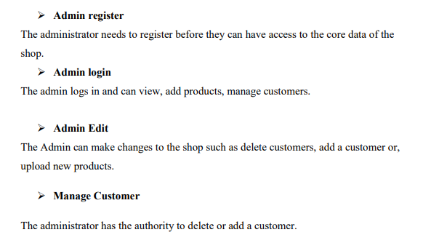

**Overview of PHP:**

PHP (recursive acronym for PHP : Hypertext Preprocessor) is a widely-used open source general-purpose scripting language that is especially suited for web development and can be embedded into HTML.

PHP is a server-side scripting language, especially suited for the creation of dynamic web pages. This programming language offers web developers a large selection of instruments. PHP, which has become the basis for many web applications, allows easy insertion in HTML code and connection to MYSQL and PgSQL Databases.

### To create a new PHP page

Do one of the following :

* + - * On the File menu, point to New, and then click PHP.
      * On the File menu, click New. In the New dialog box, on the Page tab, click General, then click PHP, and then click OK.

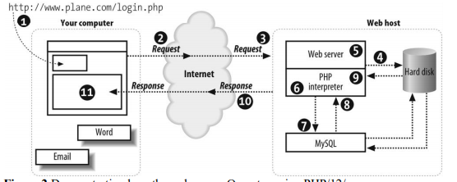

### PHP script blocks

* + - * A PHP script block can appear anywhere in a .php page, and each page can contain more than one PHP script block. A PHP script block must begin with <?php and end with ?>.
      * The following is an example of a PHP script block:

<?php

echo "Hello World";

?>

### Features of PHP:

* Loosely Typed Language : PHP supports variable usage without declaring its data type. It will be taken at the time of the execution based on the type of data it has on its value.
* Cross Platform Compatibility : It is used to create the desktop application by using advanced PHP features.
* variable variables : PHP allows changing the variable name dynamically by using variable variables.
* Real-Time Access Monitoring : PHP provides access logging by creating the summary of recent accesses for the user.
* Magic Method : PHP has built in methods starts with (double underscore). These methods can’t be called directly. Rather, it will be called on the event basis.

For example, clone() will be called, when the clone keyword is used.

* Error Reporting : It has some predefined error reporting constants to generate a warning or error notice.

For example, when E_STRICT is enabled, a warning about deprecated methods will be generated.

* Extended Regular Expression : PHP provides REGEX methods with extensive parsing and pattern matching mechanism with remarkable speed.
* nowdocs and heredocs String : PHP provides the *nowdocs* and *heredocs* properties are used to delimit some block of context. *nowdocs* and *heredocs* are same except the context in the heredocs allow variable parsing.
* Traits : PHP is a single inheritance language. The traits concept is used to cover inheritance limitation and support inheritance at multiple levels.

##### Advantages of the PHP software development technology

The main factor of the PHP language is the practicality. This programming language gives the possibility of realization tasks in short period and high quality for the developers. This point is based on the 5 features:

* **Traditionality** : PHP programming language is rather easy for the developers that work in different spheres. It is based on C and Perl that minimized efforts for learning the **PHP software development** and HTML5 mobile web development main elements and functions. Simplicity : The PHP script could consist of 10000 symbols or even from the one line - all depends on the project requirements and development purposes. There is no necessity for additional libraries download or specific compilation points mentioned.
* **Effectiveness** : The important advantage of the PHP language is its software engine. It is not just a compiler or interpreter, it is the relaying interpreter. Such structure of the software engine makes possible of high-speed script process.

### Security of PHP software development process

* Security : **PHP software development** process gets two security categories for developers and administrators: system-level services and application-level tools. System-level is guaranteed by the safe mode work type that limits the user’s possibilities in different points.
* Application-level is realized through the standard function set with the number of strong encryption mechanisms.
* Flexibility : **PHP software development** language is easy integrated with HTML, JavaScript, XML etc.

##### Advantages of PHP

* **Open source** : It is developed and maintained by a large group of PHP developers, this will helps in creating a support community, abundant extension library.
* **Speed** : It is relative fast since it uses much system resource.
* **Easy to use** : It uses C like syntax, so for those who are familiar with C, it's very easy for them to pick up and it is very easy to create website scripts.
* **Stable** : Since it is maintained by many developers, so when bugs are found, it can be quickly fixed.
* **Powerful library support :** You can easily find functional modules you need such as PDF, Graph etc.
* **Built-in database connection modules :** You can connect to database easily using PHP, since many websites are data/content driven, so we will use database frequently, this will largely reduce the development time of web apps.
* Can be run on many platforms, including Windows, Linux and Mac, it's easy for users to find hosting service providers.

##### 

##### Disadvantages of PHP

* Security : Since it is open sourced, so all people can see the source code, if there are bugs in the source code, it can be used by people to explore the weakness of PHP.

Not suitable for large applications: Hard to maintain since it is not very modular.

##### FRAMEWORK OF PHP:

PHP framework is a library that makes the life of site developer easier by for example hiding some complexities of HTTP protocol or by adding some useful functions. For example the **CakePHP** implements so called **MVC** which makes developer to think a level higher than HTTP.

##### USE OF FRAMEWORK:

The **MVC Pattern.** The Popular **PHP** frameworks like CakePHP, CodeIgniter, Zend Framework, Symfony follow Model View Controller(MVC) design pattern which separates business logic from user interface making the code cleaner and extensible.

Advantages of PHP Framework:

There have been multiple advantages of **PHP** framework, while developing a website with a **PHP framework**. Utilizing the PHP framework can encourage website developers to show their best efforts.

PHP framework inbuilt with **robust functions**:

This framework is built with an excellent set of functions, you can abridge tough tasks and get quick results from PHP coding. PHP framework is freeware with various functions; utilizing these functions you can simplify the code in PHP.

##### **Centralized Database:**

Database is the crucial factor for each project. It is the central point, where the entire data of the project are saved and called for, when required. MySQL is utilized for the database requirements for PHP.

##### Use wire-frame before coding:

It is always beneficial to use wire frame before you start coding in PHP. The practice of using wire-frame, boost your web development projects effectively. Make sure the wire-frame club and all its elements are integrated perfectly.

##### Disadvantages of PHP Framework:

Everything has two aspects. So, PHP framework has also some disadvantages Let's have a brief look of the disadvantages of PHP framework.Poor error handling method:

PHP framework has a bad error handling method! It is not an proper solution for the PHP developers. Therefore, as a qualified PHP developer, you will have to overcome with it.

##### **PHP is Unsecured:**

It is an open source system, so anyone can see and change the source code! If any web developers, who have great idea and experience in bug finding in the code can exploit your coding practice.

##### **Core PHP:**

It is very basic **PHP**. It is used to create dynamic web pages. It works without any additional library.

**PROJECT DESIGN**

Administrators Detailed Attribute

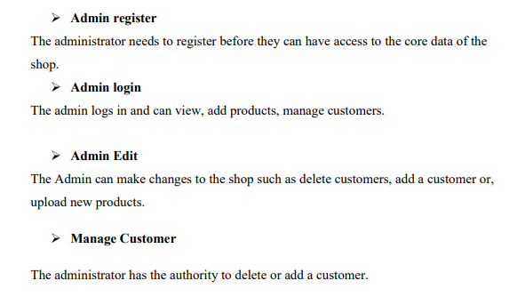

Customer Detailed Attribute

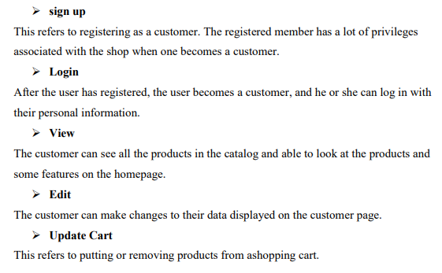

Data Flow Diagram:

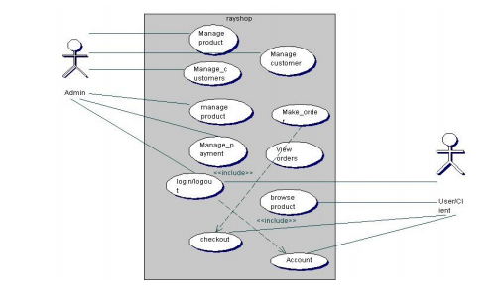

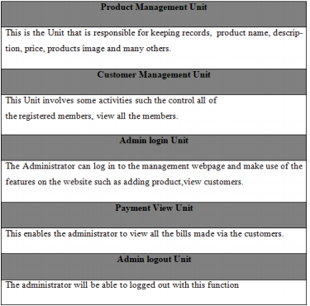

User registration

The Users will use their exclusive information to register.

After filling the form and submitting it, the html5 checks to see if all the fields entered by the user are 16 correct.

If the area is not correctly filled the user remains on the same pagebut if the requirements are met the data goesto the database (table "customers") and saves the information of the User.

The User then becomes a customer, and he or she is then directed to the login webpage of the shop.

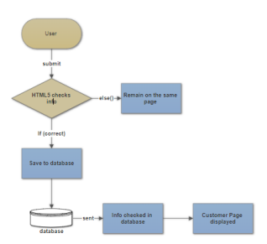

Customer login

The customer will use his particular data e-mail and passwordto log into the shop.

After submitting the form, the html5 checks if all the fields have been filled correctly.

If the condition is not met the customer remains on the same page but if the fields are correctly filled the customer login information is sent to the database to check if the data entered into the areas are same as the ones used to register to the database.

If it is correct, 17 the customer is redirected to his homepage, and he can successfully pick products and check out if they are done shopping. Figure 7 shows the flow diagram of customer login

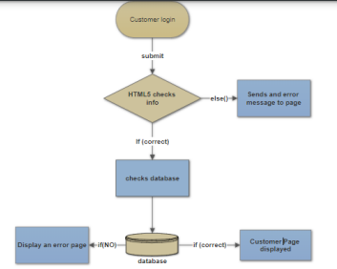

Administrator Registration

The Administrator will use his particular data such as name, e-mail, and password. After submitting the form, the html5 checks to see if all the fields entered by the adminis correct. If the filed are not correctly filed, or conditions are not met the admin remains on the same page but if all requirements are met admin's information goesto the database and saves the data in the "Admins" in the database. After that, the administrator is directed to the admin webpage to log in. The Figure 8 shows the administrator registration diagram.

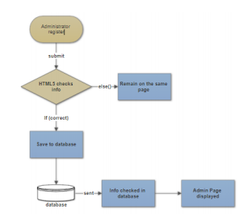

Administrator Login

When the admin logs into the Administrators webpage the html5 checks to see if conditions are met when logging in.

If all the information provided are correct, the data is sent to the database to check if the data corresponds to the information used to register.

If it matches to the information provided by the Administrator, a page opens, and the admin can have access to the administrator's webpage if not the administrator is restricted from having access to management webpage.

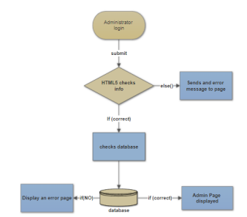

MVC UNIT OF SHOPPING CART:

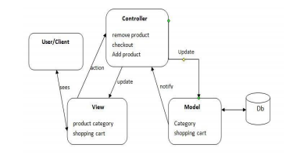

The three parts of the MVC software structure perform the following: View – shows the interface that the person sees (usually, a webpage).

The view additives provide records to the user and moves to the Controller for manipulating data. Model – defines the statistics for the software (typically, the facts is saved in a database(DB)).

The controller provides the interface between the View and the model.

Back-end Module layout

This includes Units such as products, brand, category, orders and, customer management modules.

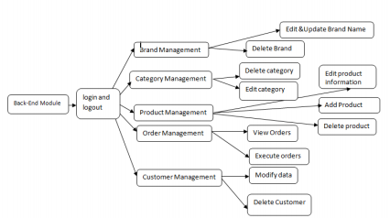

The back-end module/Unit is used to manage the backend of the shop. This is only available to the administrators.

They can manipulate the shop to suit the conditions they have set for the shop.

They also make sure that customers have a good experience when visiting the shop by updating products, deleting products, executing orders to warehouses, and managing customers

**TABLE DESIGN**

**DATABASE GUI DESIGN**

Design for database and GUI application

**Database**

MySQL database is used to save software data for this project.

MySQL is relational database management, and it is free of charge. All of the informationis kept in a selectedtable, and every table has particular range columns and rows. It has eight tables named as admins, brands, cart, categories, customers, orders, payments and products. the ER-diagram of the eight tables in the database.

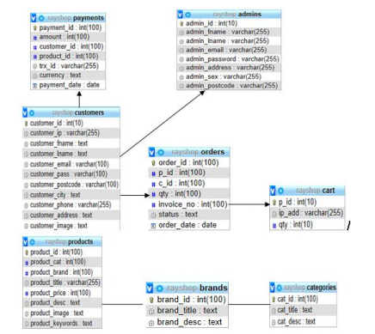

The ER-diagram has a specific name and it consists of columns and rows. For each table, we need to mark at the least one area as a primary key. The primary key is usually specified in a particular table. The table "admins" is created to store all the Admin’ information.

It consists of eight distinctive fields referred to as columns to shop admin id, first name, last name, email, and password.

The email and the password are essential because they are needed for one to login into the shop.

"admin_id" is the primary KEY. Many columns of one table may be described as primary KEY. Each column has a name, a datatype and different nonobligatory attributes.

only displays different brands of products, brand identity and also the descriptions of the multiple brands.

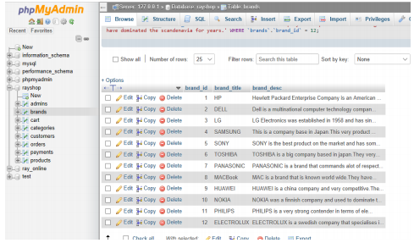

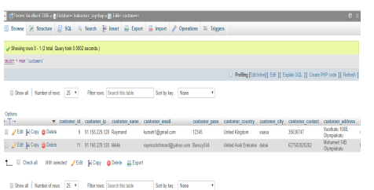

The customers who have registered to the online shop have their data automatically stored in the database.

This information is only available to the technical administrators. The administrator can delete, edit, and update customer information

**HOMEPAGE**



**ABOUT US**

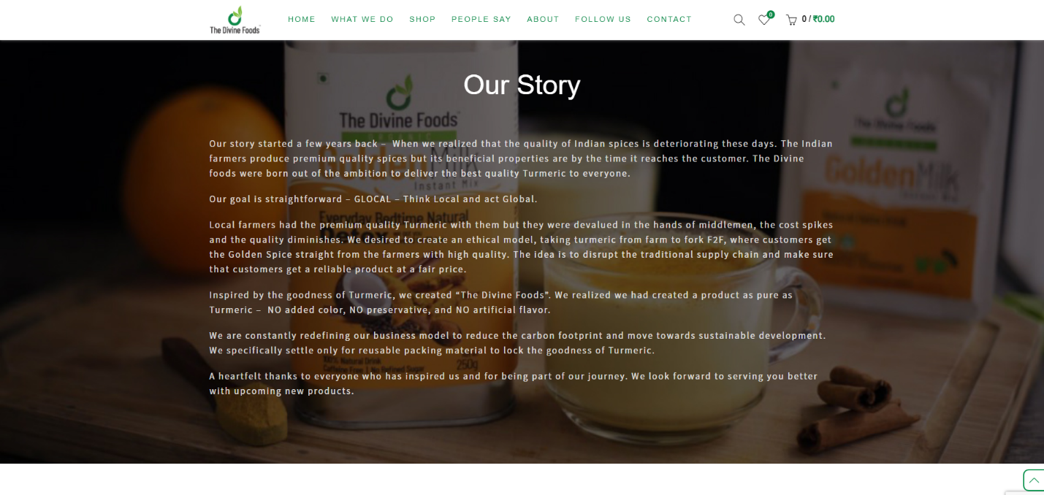

**CONTACT US**

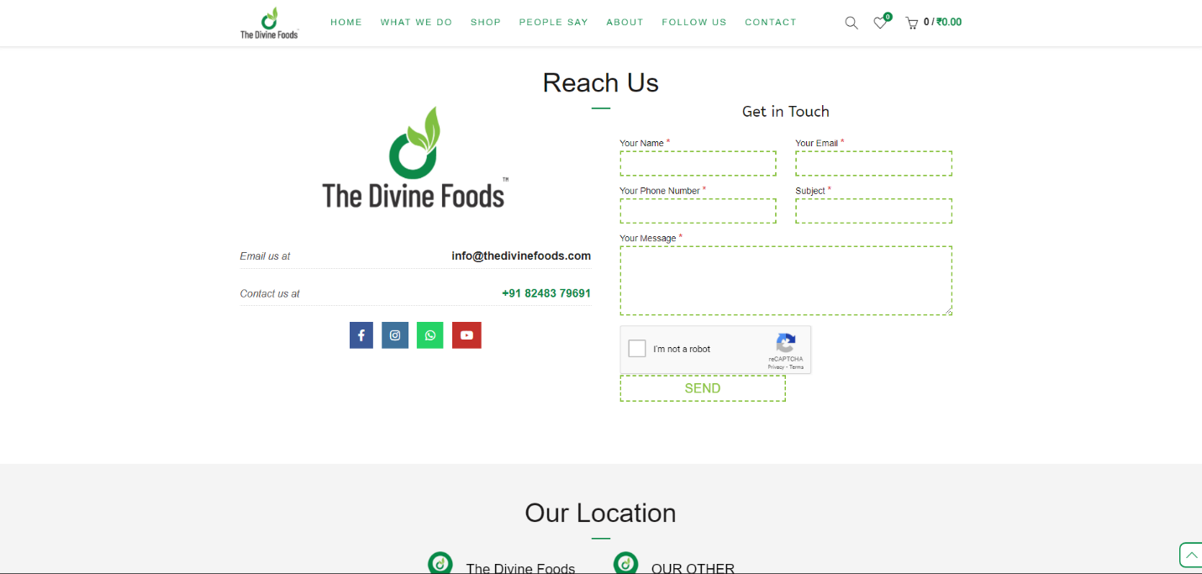

**SHOP**

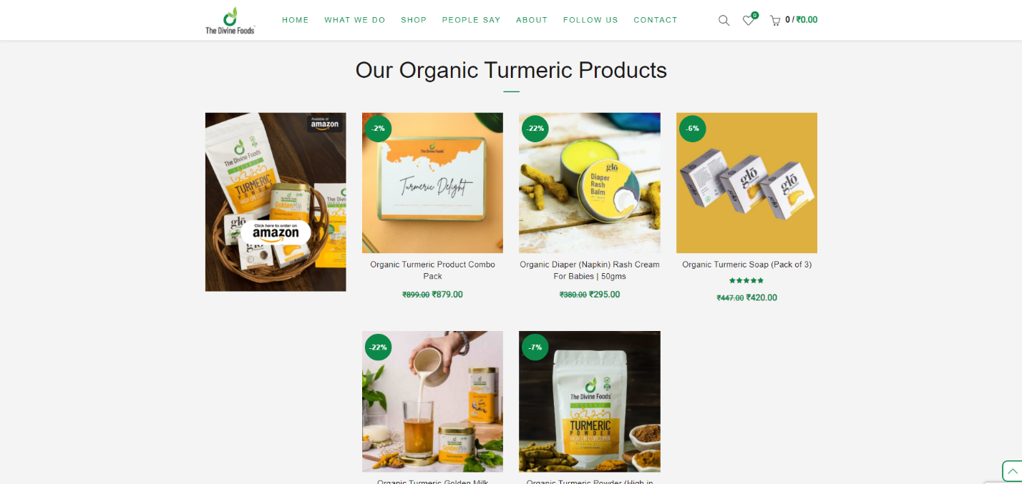

**LOGIN**

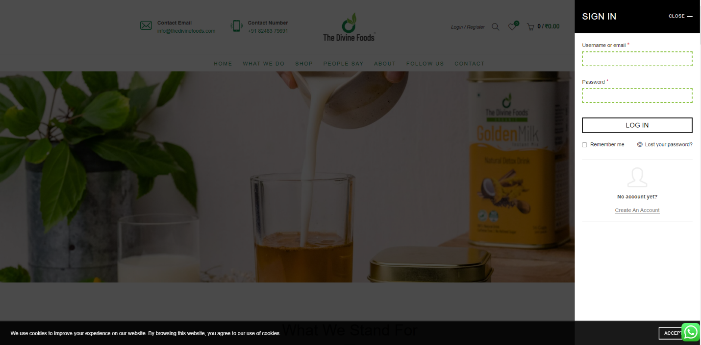

**Register**

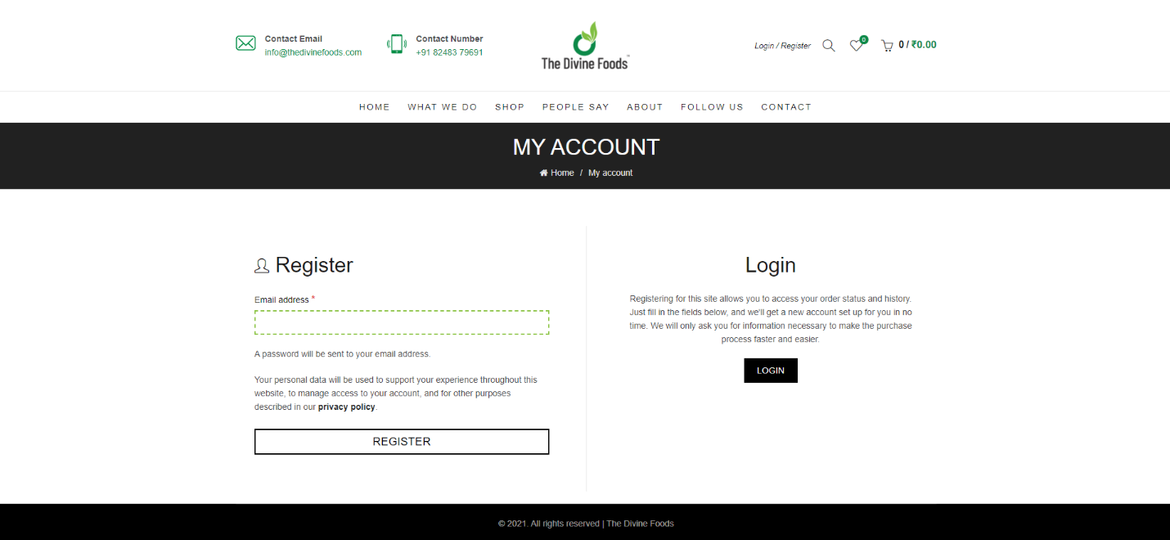

**Instagram List**

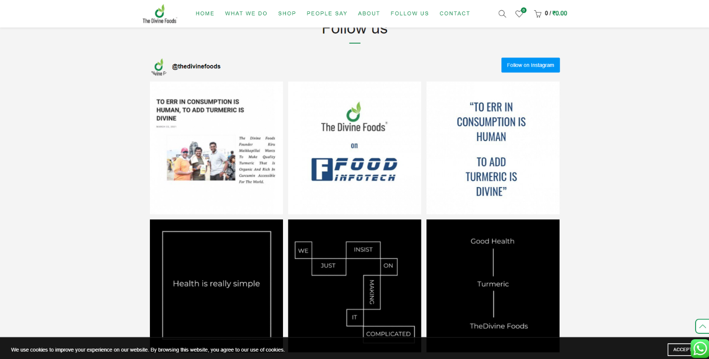

**Products**

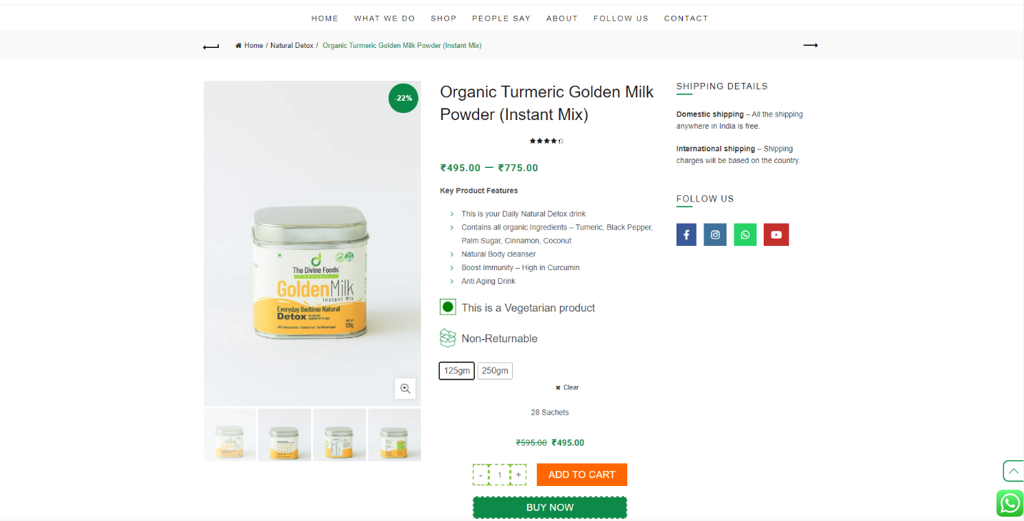

**Checkout**

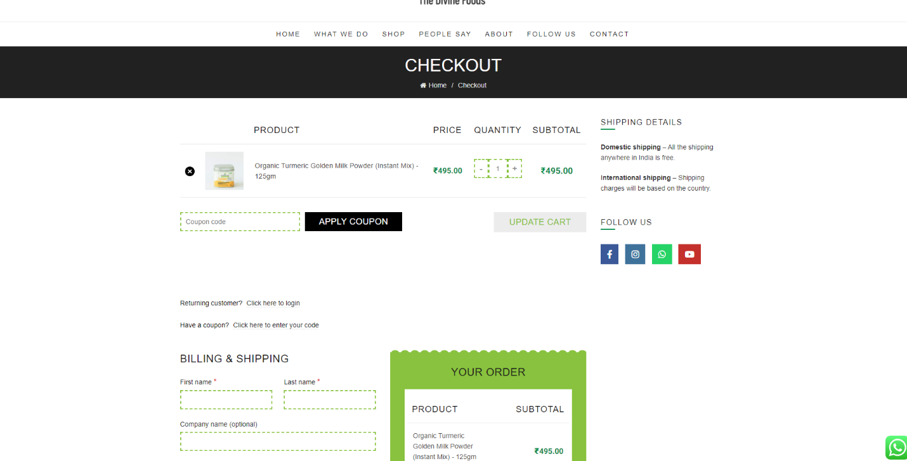

**Payment Gateway**

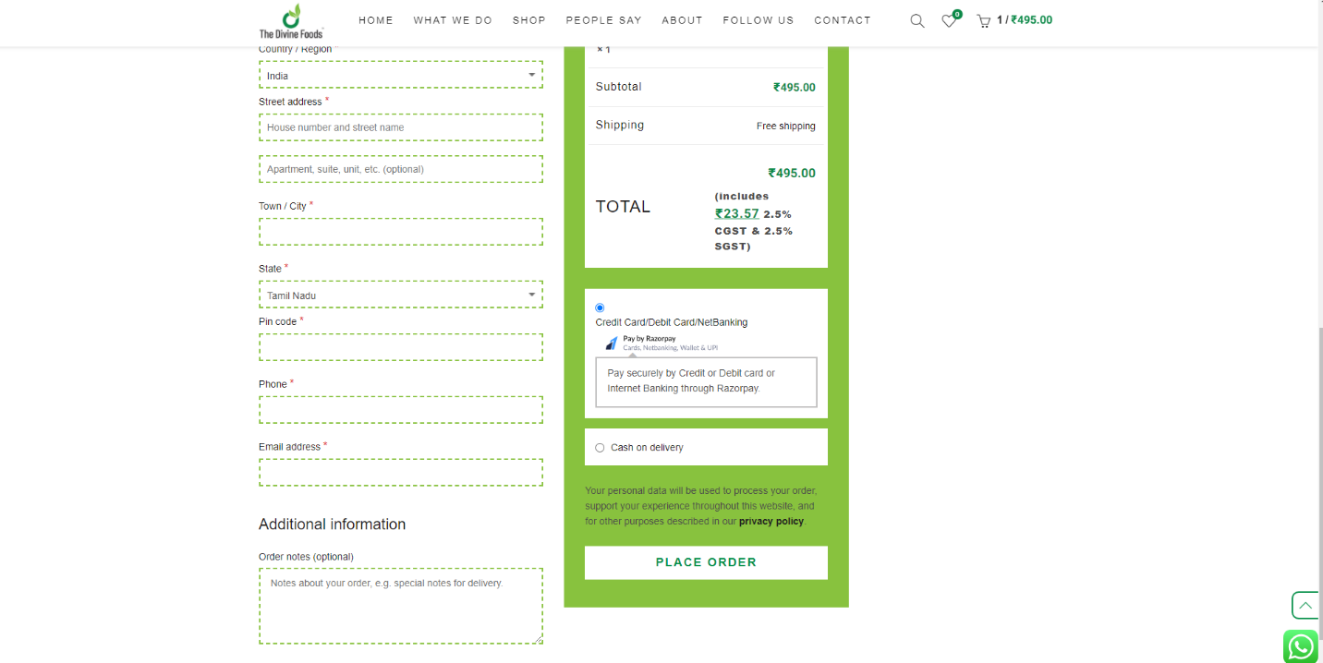

**Install WooCommerce Plugin**

Follow the below steps to install and setup WooCommerce:

1. Login to your WordPress dashboard
2. Go to Plugins > Add New
3. Now type “woo-commerce” in the search field. The first search result you’ll see is WooCommerce.
4. Installing WooCommerce in WordPress
5. Next, click the “Install Now” button next to the plugin and activate the plugin.

**Activating WooCommerce in WordPress**

Next, you’ll see WooCommerce’s on-screen setup wizard. To start the wizard, click “Let’s go!”

WooCommerce’s on-screen setup wizard

The first step in the wizard is about creating below pages:

**Shop:**

Your all products will appear here

**Cart:**

This is the shopping cart where your customers can modify their order before proceeding to the checkout page.

**Checkout:**

This is where your customers choose the delivery method and pay for whatever they’ve bought.

**My Account:**

This is where your registered customers can view their past orders and manage other details.

After creating the required pages, all you need to do is click the “Continue” button to proceed next.

The next screen you’ll see is to set up your store location, currency, preferred units, etc.

**WooCommerce store locale setup**

* Once you’re done, click the “Continue” button.
* On the next screen, you can select if you’re going to be shipping physical goods or not. If you check the box, WooCommerce will pre-set the remaining shipping-related details in the settings.
* Next, check the main tax box, if you’re going to charge sales tax. Once you check the box, a new set of boxes will appear and inform you of what’s going to happen next.

**WooCommerce main tax box**

Next, click the “Continue” button and you’ll be asked to set up your preferred payment method.

**Integrating payment methods in WooCommerce**

* PayPal and Stripe are the most popular payment options. We recommend that you integrate your site with both PayPal and Stripe. When you are done, click “Continue” to proceed.
* The next screen you’ll see is just a confirmation page. Now, you’ve just built a blank e-commerce store with WooCommerce!

**Installing and activating a theme**

The WordPress theme directory is a great place to find free themes or you can check this list of the top 100 free WordPress themes. In this guide, we will use the free Responsive themes (one of our own popular WordPress themes with 50,000+ active installations) that can be installed and used as any standard free WordPress theme.

Follow the below steps to install the Responsive theme manually from the WordPress admin dashboard:

1. Download the latest Responsive theme from the WordPress repository
2. Responsive theme- WordPress.org page
3. Login to your WordPress Dashboard
4. From your WordPress dashboard, go to Appearance > Themes > Add New
5. Adding Responsive theme in WordPress
6. Upload the downloaded theme zip file
7. Uploading Responsive theme zip file in WordPress
8. Install the Responsive theme
9. Activate it
10. Install & Activate Responsive Ready Site Importer Plugin

The Responsive Ready Sites Importer plugin extends the functionality of the popular Responsive theme by adding the ready site importer feature. It comes with free ready to use WordPress website templates that can be easily customized using the wp bakery page builder.

First, download the latest free Responsive Ready Sites Importer by visiting

**Responsive ready sites importer plugin- WordPress.org**

After downloading the plugin zip file, follow the below steps to install the Responsive Ready Sites Importer Plugin manually from the WordPress admin dashboard:

1. Login to your WordPress Dashboard
2. Go to Plugins > Add New
3. Adding new WordPress plugin
4. Upload the downloaded plugin zip file
5. Uploading WordPress plugin zip file
6. Install the Responsive Ready Sites Importer plugin
7. Activate it

* Now that you have activated the importer plugin, it’s time to import an eCommerce website template that comes free with the Responsive theme. To do so, follow the steps below:
* From the WordPress dashboard navigate to Appearance > Ready Sites and select any eCommerce template like shop, etc. For demonstration, we’ll select the Ecommerce cosmetics template in this article.
* Responsive theme ready sites templates

2. On the preview page, you will see the website and you can see the “Import Site” button.

3. On clicking the Import Site button on the preview page you will see actions that will be taken to import the website.

4. Now you can click on the Import Site button and the import process will start. You will see a checkmark in front of the actions that are completed.

5. After Import is complete you will see the Launch Site button which will take you to the newly imported site.

6. Next, you will need to add your site logo, add and style the navigation menu. With Responsive theme you can easily make these changes to your eCommerce site. Check this guide.

**How to add product to your eCommerce site?**

With the above steps completed, your eCommerce site is ready to display your first product. Follow the steps below to add your first product:

1. Go to your WordPress dashboard > Products > Add new
2. Adding WooCommerce product Next, you need to:
3. Adding WooCommerce product details
4. Add product title
5. Add your product description
6. Select your product category
7. Set your product price
8. Set your main product image
9. Add additional product images to showcase your product
10. Add a short description of your product
11. Add product tags to organize your database of products better.
12. Once you’re done, click on the “Publish” button to make your first product live.

**How to customize your eCommerce store page?**

Follow the steps below to customize the store page layout using customizer:

* From the WordPress dashboard navigate to Appearance > Customize
* Next, select Product Catalog Options > Layout
* On the next page, you will see different options to change the layout of your store page.
* WooCommerce layout customizing options

**Below are the options which you will see:**

**Main content width:**

You can adjust the width of the main content.

**Sidebar position:**

You can change the position of the sidebar. You can choose to put your sidebar on the Right side, Left Side, or No sidebar.

**Catalog view:**

You can change the view of your product catalog. You can choose whether a grid or list view be set as the default.

**Shop pagination:**

This option allows you to set up shop pagination without coding. You can choose the Default option to set up numeric shop pagination and Infinite option to set up infinite pagination which can offer a more fluid experience to your website visitors who want to quickly browse through lots of products without waiting for a new page load.

**Shop pagination style:**

You can change this style to Circle or Square.

**Shop quick view:**

You can manage the Quick view which shows product details in a lightbox. You’ll get below options:

* On Image
* On Image Click
* After Summary

**Content alignment:**

You can change the alignment of your shop contents.

**Shop elements:**

You can Show or Hide any particular shop element and also drag up-down to change the position of a particular shop element.

**Sale notification:**

You can set sale notifications to default, custom ring, or none.

**Sale bubble style:**

You can change this style to Circle, Circle outline, Square, or Square outline.

**How to customize your eCommerce product page?**

Follow the steps below to customize the product page layout using customizer:

* From the WordPress dashboard navigate to Appearance > Customize
* Next, select Product Options > Layout
* On the next page, you will see different options to change the layout of your product page.
* WooCommerce product layout customize options

**Below are the options which you will see:**

**Main content width:**

You can adjust the width of the main content.

**Sidebar position:**

You can change the position of the sidebar. You can choose to put your sidebar on Right side, Left Side, or No sidebar.

**Gallery layout:**

You can change the product gallery layout to horizontal or vertical.

**Single product structure:**

You can Show or Hide any particular product element and also drag up-down to change the position of a particular product element.

**PLUGINS**

* Mail Chimp
* Yoast SEO
* Woo-commerce

**MailChimp for WooCommerce**

**Mailchimp**

One of the crucial ways to grow your eCommerce business is by increasing your subscriber base. This way, you can send out new product launch, announcements, and any other communication periodically.

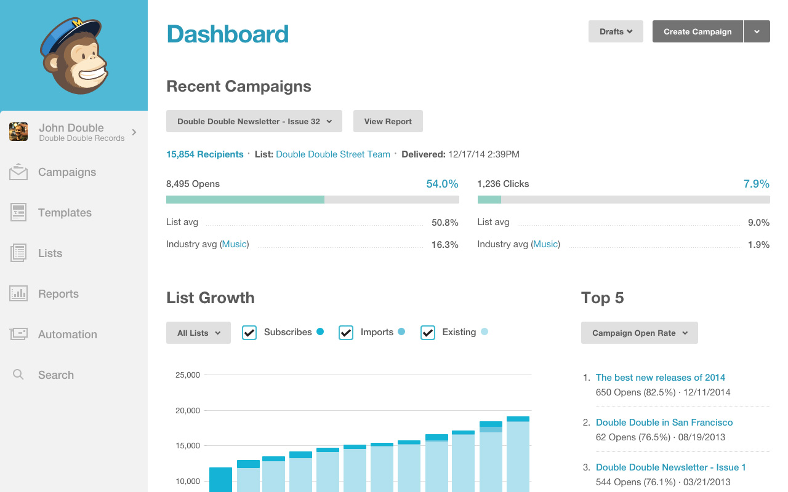

MailChimp is a popular email marketing tool that enables you to build an email list and send mass emails. Using Mailchimps’s WooCommerce plugin you can collect emails via your website. You can create forms on your site through which you can build your newsletter list. It also integrates with major contact form plugins giving you one more avenue to build your database.

**Yoast SEO**

Yoast SEO is a must-have plugin if you want to improve the rankings of your eCommerce website in the search engine. This plugin helps with SEO friendly content, XML sitemaps and provides an easy template to add a title, meta description, and other SEO tags.

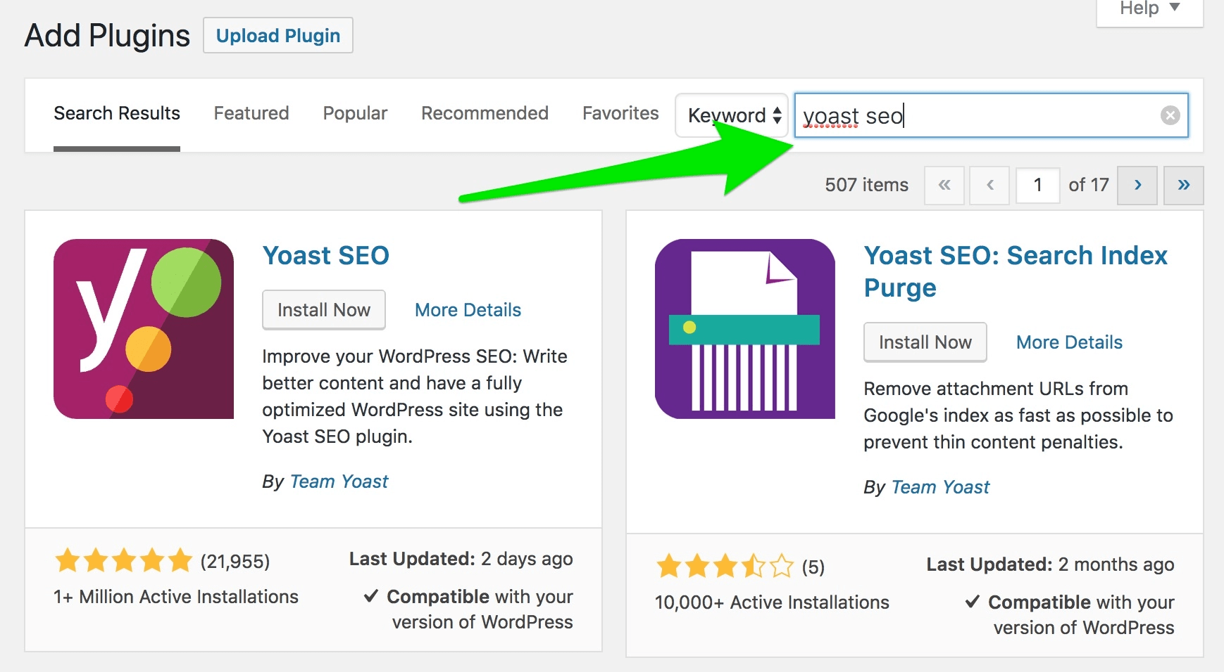

**What Is SEO?**

Search engine optimization (SEO) is the practice of getting targeted traffic to a website from a search engine’s organic rankings. Common tasks associated with SEO include creating high-quality content, optimizing content around specific keywords, and building backlinks.

**In other words:**

* SEO is all about improving a site’s rankings in the organic (non-paid) section of the search results.
* SEO is about improving a site organic ranking
* The main benefit of ranking for a specific keyword is that you can get “free” traffic to your site, month after month.

**How Search Engines Work**

* Organic vs. Paid Results
* Why Is SEO Important?
* Customers and Keywords
* SEO-Friendly Content
* High-Quality Content Examples
* On-Page SEO Basics
* Intro to Technical SEO
* Link Building Basics
* Search Intent
* Emerging SEO Trends
* How Search Engines Work
* Now it’s time to learn how search engines like Google actually work.

When you search for something in Google (or any other search engine), an algorithm works in real-time to bring you what that search engine considers the “best” result.

Specifically, Google scans its index of “hundreds of billions” of pages in order to find a set of results that will best answer your search.

**How does Google determine the “best” result?**

Even though Google doesn’t make the inner workings of its algorithm public, based on filed patents and statements from Google, we know that websites and web pages are ranked based on:

**Relevancy**

* If you search for “chocolate chip cookie recipes”, you don’t want to see web pages about truck tires.
* That’s why Google looks first-and-foremost for pages that are closely-related to your keyword.
* However, Google doesn’t simply rank “the most relevant pages at the top”. That’s because there are thousands (or even millions) of relevant pages for every search term.
* For example, the keyword “cookie recipes” brings up 349 million results in Google:
* "cookie recipes" – SERPs
* So to put the results in an order that bubbles the best to the top, they rely on three other elements of their algorithm:

**Authority**

* Authority is just like it sounds: it’s Google’s way of determining if the content is accurate and trustworthy
* The question is: how does Google know if a page is authoritative?
* They look at the number of other pages that link to that page:
* Authority judged by number of pages linked
* (Links from other pages are known as “backlinks”)
* In general, the more links a page has, the higher it will rank:

**Usefulness**

* Content can be relevant and authoritative. But if it’s not useful, Google won’t want to position that content at the top of the search results.
* Distinction between higher-quality content and useful content
* The first result you click on (“Result A”) is written by the world’s foremost expert on Paleo. And because the page has so much quality content on it, lots of people have linked to it.

**Unorganized content**

* However, the content is completely unorganized. And it’s full of jargon that most people don’t understand.
* Contrast that with another result (“Result B”).
* It’s written by someone relatively new to the Paleo Diet. And their website doesn’t have nearly as many links pointing to it.
* However, their content is organized into distinct sections. And it’s written in a way that anyone can understand:

**Useful content**

* Well, that page is going to rank highly on the “usefulness scale”. Even though Result B doesn’t have as much trust or authority as Result A, it will still perform well in Google.
* Google measures usefulness largely based on “User Experience Signals”.
* In other words: how users interact with the search results. If Google sees that people really like a particular search result, it will get a significant ranking boost:

**Positive user experience boosts ranking**

* Create a website that people love! Search engines are designed to measure different signals across the Web so they can find websites that people like most. Play right into their hands by making those signals real and not artificial.
* And now it’s time to put this stuff into practice with a step-by-step SEO tutorial.

**How SEO Works**

* SEO works by optimizing your site for the search engine that you want to rank for, whether it’s Google, Bing, Amazon or YouTube.
* Specifically, your job is to make sure that a search engine sees your site as the overall best result for a person’s search.
* How they determine the “best” result is based on an algorithm that takes into account authority, relevancy to that query, loading speed, and more.
* In most cases, when people think “search engine optimization”, they think “Google SEO”. Which is why we’re going to focus on optimizing your site for Google in this guide.

**Organic vs. Paid Results**

* Search engine result pages are separated into two distinct sections: organic and paid results.
* Organic search results (sometimes referred to as “natural” results) are natural results that rank based 100% on merit.
* In other words, there’s no way to pay Google or other search engines in order to rank higher in the organic search results.
* Search engines rank the organic search results based on hundreds of different ranking factors. But in general, organic results are deemed by Google to be the most relative, trustworthy, and authoritative websites or web pages on the subject.
* I have more details on how search engine algorithms work later on. But for now, the important thing to keep in mind is:
* When we talk about “SEO”, we’re talking about ranking your website higher up in the organic search results.

**Paid Results**

* Paid search results are ads that appear on top of or underneath the organic results. Paid results ranked by amount paid
* Paid ads are completely independent of the organic listings. Advertisers in the paid results section are “ranked” by how much they’re are willing to pay for a single visitor from a particular set of search results (known as “Pay Per Click Advertising”).

**Search Engine Marketing (SEM) types compared**

Type of SEM Ranking Speed Skill Level Required Cost Typical ROI Potential ROI Conversion Rate

**SEO** 2/5 5/5 3/5 4/5 5/5 2/5

**PPC** 5/5 3/5 5/5 2/5 4/5 4/5

**Why Is SEO Important?**

**Traffic data referrer**

As you can see, nearly 60% of all traffic on the web starts with a Google search. And if you add together traffic from other popular search engines (like Bing, Yahoo, and YouTube), 70.6% of all traffic originates from a search engine.

**Web traffic sources**

Let’s illustrate the importance of SEO with an example…

Let’s say that you run a party supply company. According to the Google Keyword Planner, 110,000 people search for “party supplies” every single month.

**Number of searches**

Considering that the first result in Google gets around 20% of all clicks, that’s 22,000 visitors to your website each month if you show up at the top.

**Number of clicks**

* But let’s quantify that – how much are those visitors worth?
* The average advertiser for that search phrase spends about 1 dollar per click. Which means that the web traffic of 22,000 visitors is worth roughly $22,000 a month.
* And that’s just for that search phrase. If your site is SEO-friendly, then you can rank for hundreds (and sometimes thousands) of different keywords.

Make My Personal tool

* This nifty-free tool helps you create a customer persona, step-by-step. At the end of the process you’ll have a detailed avatar that you can refer to again and again.
* Now that you have a customer personal, it’s time for the next step: keyword research.
* Here’s where you drill down into the exact words and phrases (search queries) that customers type into the search box.
* In general, keywords tend to fall into two main buckets: keywords people use to find what you sell (Product Keywords).

You also have keywords your target audience uses when they’re not specifically looking for what you sell (Informational Keywords).

**Google auto complete**

* I recommend typing keyword ideas into Google and jotting down any suggestions that come up.
* Second, type words and phrases into Answer The Public.
* For example, if you run a blog about the Paleo Diet, you’d type “paleo diet” into ATP:
* That question is an awesome topic for a blog post or video.
* Next, use a keyword research tool.
* Keyword tools can help you figure out how many people search for each keyword and how difficult it will be to rank on the first page of Google for that term.
* In other words, they can help you choose the best keywords from your list. There are a million and one keyword research tools out there.

Here are a few I recommend checking out:

* SEMRush
* KeywordTool.io
* Keywords Everywhere Extension
* Moz Keyword Explorer
* Seed Keywords

But the best all-around free keyword tool is Google’s Keyword Planner.

**Google Keyword Planner**

* Even though Keyword Planner was designed to help people with Google Ads campaigns, it can still help you find keywords for SEO.
* All you need to do it enter a product keyword or informational keyword into it.

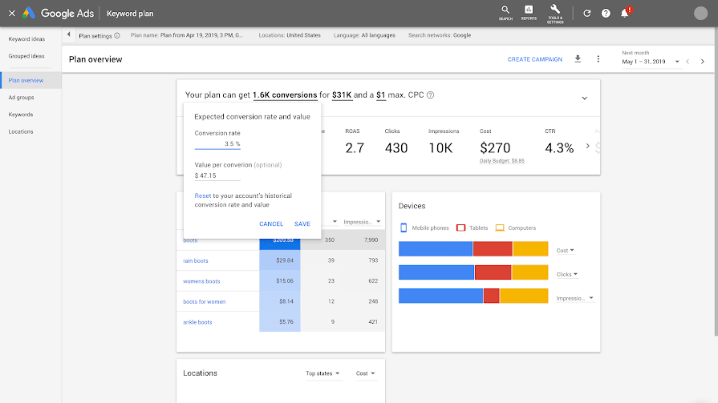

**Google Keyword Planner – Keywords**

The search volume range is kind of a pain. But it does at least give you some idea of how many times that keyword gets searched for every month.

If you do want more exact search volume data, you need to run a Google Ads campaign.

**Google Keyword Planner – Start campaign**

You can also use a 3rd party tool (like Ahrefs, Semrush, etc.) that have more precise search volume info.

In general, I wouldn’t worry about the ranges. They’re still helpful for figuring out relative search volume between different keywords.

**Why?**

Because long tail phrases are less competitive.

**Number of keywords: Competition vs. Conversion**

* Once you get the hang of SEO, you can start targeting more competitive keywords. But when you’re just starting out, stick to long tail terms.
* For example, when I started my blog, almost 100% of the content I put out was designed to rank for long tail, informational keywords, like “How to get high-quality backlinks”:

**High quality backlinks**

As my site’s authority increased I went after shorter phrases that were more competitive, like “backlinks”:

**Hub Backlinks**

If you want to see the exact process that I use to find keywords, I recommend setting aside a few minutes to watch this short video:

**SEO-Friendly Content**

* It’s no secret that SEO and content are closely linked.
* In general, the better content you put out there, the higher you’ll rank. It’s (obviously) not that simple. But it’s a good rule of thumb to follow as you write content for SEO.
* With that, here are more details on how to create SEO-friendly content.
* Creating Content for Product and Service Pages
* Content for product and service pages should still be high-quality. But that doesn’t mean that you want your product pages to read like blog posts.
* In fact, the main goal of your product pages should be to convert browsers into leads and customers. That’s why you want your product pages to focus on the features and benefits that your product offers.

**Baremetrics – Homepage**

In many ways, even though this isn’t a blog post or article, it’s still high-quality content. As you can see, the well-designed page and outlines key product features.

**Baremetrics – Features**

So someone searching for a Product Keyword like “revenue forecasting software” would get a lot of value from this page… even though the main goal of the page is to get you to sign up for a trial.

**Creating High-Quality Blog Content**

* When most people say things like “content is king”, they’re talking about the type of insanely useful content that gets published on blogs.
* And there’s no doubt that producing awesome content can help improve your Google rankings.

**Google Analytics**

The tool allows you to track websites, blogs, and social networks. In addition, it puts at your disposal predetermined and customizable reports. As indicated in its entry in Wikipedia, Analytics “offers grouped information of the traffic that arrives at the websites according to the audience, the acquisition, the behavior, and the conversions carried out on the website.” And also, Google Analytics is the dominant tool. It offers more data and metrics than any other.

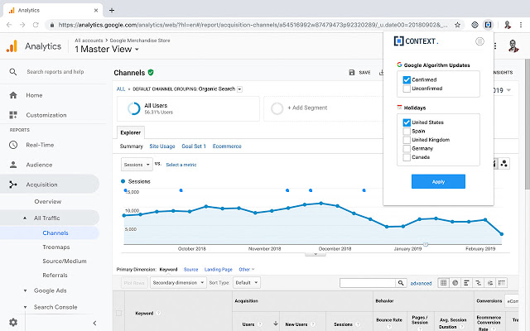

It works on elements as varied and vital as the following:

* Number of visits
* Their duration
* Sources of traffic
* Visited pages
* It also acts in sections such as:
* Your users preferred sections
* Keywords used
* Technical details of visitors’ devices. That would enter the browsers that users use or their mobile operating systems.

But what makes Analytics a complete tool is that it is compatible with the rest of Google’s tools. Thus, it is possible to combine Analytics with AdWords, Blogger or YouTube. In fact, all Google tools in which visits and traffic are counted can be mixed and complemented with Google Analytics. In addition, there are different attractive resources for Analytics available in Google Chrome. You can play with them too.

The free Google Analytics tool collects data using a combination of cookies, browsers and the JavaScript code discussed above.

The analytics program can collect information from your site thanks to the JavaScript code that you must include in your pages and the cookies that are generated once the user accesses the web through a browser.

In this way, all Google Analytics records the activity of your user from the moment he arrives until he leaves your website and transforms it into different reports with graphs and statistical data to make it easier to know the evolution.

Its operation is based on three processes: the collection of data, the processing thereof and the creation of reports. However, to start with the process, as in any strategy you should set some objectives.

Also, although there are three important aspects, to offer you complete information, we will even talk about the configuration.

1. **Data Processing**

* Once the interactions of a user have been collected, Google Analytics begins the data processing to transform the raw data into useful data that gives you knowledge. To process them, each of the data sections is analyzed separately. That is, their attributes are divided.
* Google Analytics transforms each attribute into elements that it calls ‘fields’. In this way, for example, the IP address will become the “Visitor’s IP” field. Each section or line provides several attributes, and each of them is stored in different areas.
* If you work with Google Analytics every day it is likely that you have faced the definition of the attribution model that helps you extract value from the data. It is very important that you define the model very well, in this way you will improve the results.

1. **Settings**

* Google Analytics applies its settings (for example, filters) to raw data. When the data has been processed, it is stored in a database. Once processed and inserted into the database, it is no longer possible to modify them.
* This way you can control how this data appears in the Analytics profiles that you have created in your account.

1. **Report generation**

* The resulting reports can be consulted either from the Google Analytics web service itself, www.google.es/analytics or from other spaces for which it is necessary to use the reporting APIs.
* Each report is created based on field comparisons. That is, aspects such as the visitor’s city or its conversion rate are taken into account.
* Finally, once the data is stored in the database, the process is terminated.

**Google Webmaster**

Google Search Console is a free tool offered by Google to help website owners monitor their website’s presence in Google search results.

It helps you track search rankings along with keeping you updated about site errors, security issues, and indexing issues that may affect your website’s search performance.

If you are serious about WordPress SEO, then you need to add it to Google webmaster tools from day one.

That being, let’s take a look at how to easily add your site to Google Search Console.

Adding Your WordPress Site to Google Search Console

First, you need to visit the Google Search Console website and click on the ‘Start Now’ button.

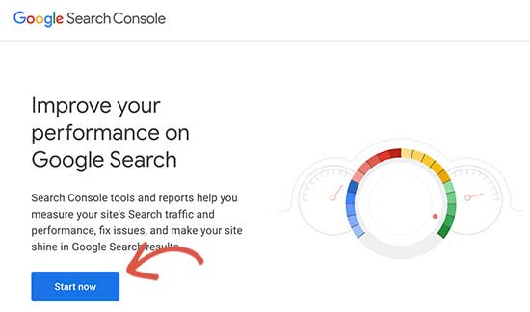

Next, you’ll need to sign in with your Google / Gmail account.

Once logged in, you’ll be asked to enter your website URL.

There are two methods for site verification: domain name or URL prefix. We recommend the URL prefix method because it is more flexible.

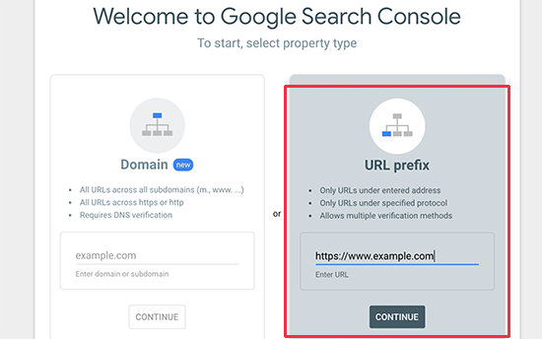

Keep in mind that Google considers an HTTP and HTTPS as two different protocols. It also considers https://www.example.com and https://example.com as two different websites.

You need to enter the correct website URL used by WordPress.

If you are unsure, then there is an easy way to find out the exact URL you need to enter. Simply login to your WordPress admin area and go to Settings » General page.

There you will see your website’s URL in the site address field.

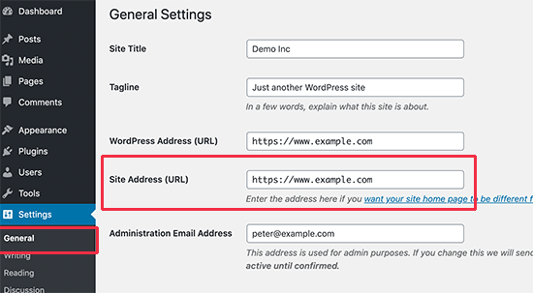

Then paste the code you copied from Google Search Console into the “Google Verification Code” box.

Don’t forget to click on the ‘Save Changes’ button to store your changes.

You can now go back to Google Search Console settings and click on the ‘Verify’ button.

Google Search Console will now look for the HTML tag in your website code and will show you a success message

That’s all. You have successfully added your site to the Google Search Console (Webmaster tools). You can now click on the ‘Go to Property’ link to visit your Google Search Console dashboard.

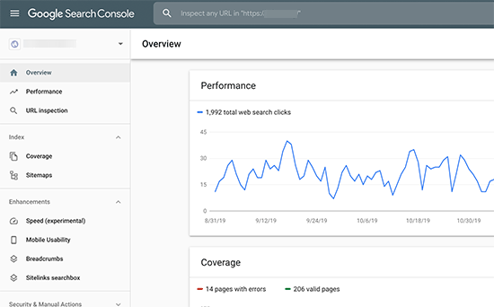

**Conclusion**

* Last but not least! Post a lot of reviews and testimonials on your website. People love to read other customers’ experiences before becoming a customer themselves. Post a few negative ones too. This section should not look all made up to suit your business.
* Ecommerce has made the world a much smaller place, thanks to the Internet. It is convenient, fast, and easy. The number of people turning to e-Shopping is only going to rise as time goes by. So make your business go online, choose a good e-commerce WordPress theme and set up a clutter-free and easy to use eCommerce website, and see your sales and profits rise.

**BIBLIOGRAPHY:**

/1/www.w3school.com

/3/CSS3 characteristic and attributes 3.05.2018

/2/php features. 08.03.2018

http://www.biogem.org/downloads/notes/PHP%20-

%20Hypertext%20Preprocessor.pdf

/4/Javascript academic. Accessed 09.03.2018

/4/http://www.w3schools.com/js/default.asp

<https://dev.mysql.com/doc/apis-php/en/apis-php-pdo-mysql.html>

/5/Documentation for mysql/ 05.01.2018

/6/UML idea. access 1.05.2018

https://en.wikipedia.org/wiki/Unified_Modeling_Language

/7/XAMPP 2.05.2018

https://www.apachefriends.org/index.html

/9/PhpMyAdmin. 5.05.2018

https://www.phpmyadmin.internet/

/8/Bracket editor 5.05.2018

https://en.wikipedia.org/wiki/Brackets_(text_editor)

/10/PayPal developer and Sandbox account 5.05.2018

<https://developer.paypal.com/developer/accounts/>

/11/The basic diagram of the HTML/HTML5 5/24/2018